Android Option Menu Example

Let's see how to create menu in android. Let's see the simple option menu example that contains three menu items.

activity_main.xml

We have only one textview in this file.

*File: activity_main.xml*

1. **<RelativeLayout** xmlns:androclass="http://schemas.android.com/apk/res/android"
2. xmlns:tools="http://schemas.android.com/tools"
3. android:layout_width="match_parent"
4. android:layout_height="match_parent"
5. android:paddingBottom="@dimen/activity_vertical_margin"
6. android:paddingLeft="@dimen/activity_horizontal_margin"
7. android:paddingRight="@dimen/activity_horizontal_margin"
8. android:paddingTop="@dimen/activity_vertical_margin"
9. tools:context=".MainActivity" **>**
11. **<TextView**
12. android:layout_width="wrap_content"
13. android:layout_height="wrap_content"
14. android:text="@string/hello_world" **/>**
16. **</RelativeLayout>**

menu_main.xml

It contains three items as show below. It is created automatically inside the res/menu directory.

*File: menu_main.xml*

1. **<menu** xmlns:androclass="http://schemas.android.com/apk/res/android" **>**
2. **<item**  android:id="@+id/item1"
3. android:title="Item 1"**/>**
4. **<item**  android:id="@+id/item2"
5. android:title="Item 2"**/>**
6. **<item**  android:id="@+id/item3"
7. android:title="Item 3"**/>**
8. **</menu>**

Activity class

This class displays the content of menu.xml file and performs event handling on clicking the menu items.

*File: MainActivity.java*

1. **package** com.javatpoint.optionmenu;
2. **import** android.os.Bundle;
3. **import** android.app.Activity;
4. **import** android.view.Menu;
5. **import** android.view.MenuItem;
6. **import** android.widget.Toast;
7. **public** **class** MainActivity **extends** Activity {
8. @Override
9. **protected** **void** onCreate(Bundle savedInstanceState) {
10. **super**.onCreate(savedInstanceState);
11. setContentView(R.layout.activity_main);
12. }
13. @Override
14. **public** **boolean** onCreateOptionsMenu(Menu menu) {
15. // Inflate the menu; this adds items to the action bar if it is present.
16. getMenuInflater().inflate(R.menu.main, menu);//Menu Resource, Menu
17. **return** **true**;
18. }
19. @Override
20. **public** **boolean** onOptionsItemSelected(MenuItem item) {
21. **switch** (item.getItemId()) {
22. **case** R.id.item1:
23. Toast.makeText(getApplicationContext(),"Item 1 Selected",Toast.LENGTH_LONG).show();
24. **return** **true**;
25. **case** R.id.item2:
26. Toast.makeText(getApplicationContext(),"Item 2 Selected",Toast.LENGTH_LONG).show();
27. **return** **true**;
28. **case** R.id.item3:
29. Toast.makeText(getApplicationContext(),"Item 3 Selected",Toast.LENGTH_LONG).show();
30. **return** **true**;
31. **default**:
32. **return** **super**.onOptionsItemSelected(item);
33. }
34. }
35. }

[download this android example](https://www.javatpoint.com/src/android/OptionMenu.zip)

Output:

Output without clicking on the menu button.

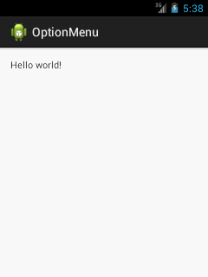

Output after clicking on the menu button.

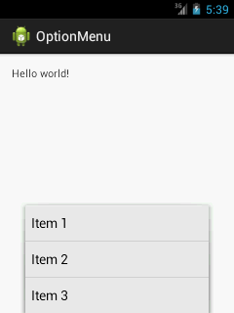

Output after clicking on the second menu item .

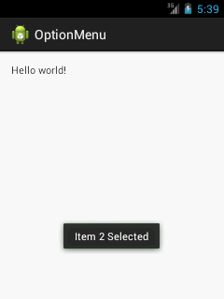

Option Menu with Icon

You need to have icon images inside the res/drawable directory. The android:icon element is used to display the icon on the option menu. You can write the string information in the strings.xml file. But we have written it inside the menu_main.xml file.

*File: menu_main.xml*

1. **<menu** xmlns:androclass="http://schemas.android.com/apk/res/android" **>**
2. **<item**  android:id="@+id/item1"
3. android:icon="@drawable/add"
4. android:title="Item 1"**/>**
5. **<item**  android:id="@+id/item2"
6. android:icon="@drawable/minus"
7. android:title="Item 2"**/>**
8. **<item**  android:id="@+id/item3"
9. android:icon="@drawable/delete"
10. android:title="Item 3"**/>**
11. **</menu>**